The basic idea about PageRank

<https://learning.edx.org/course/course-v1:AdelaideX+BigDataX+1T2021/block-v1:AdelaideX+BigDataX+1T2021+type@sequential+block@a490094f2471468ab0f8127434389d41/block-v1:AdelaideX+BigDataX+1T2021+type@vertical+block@f4db53224fd34ffa85e50c9faa4d0d58>

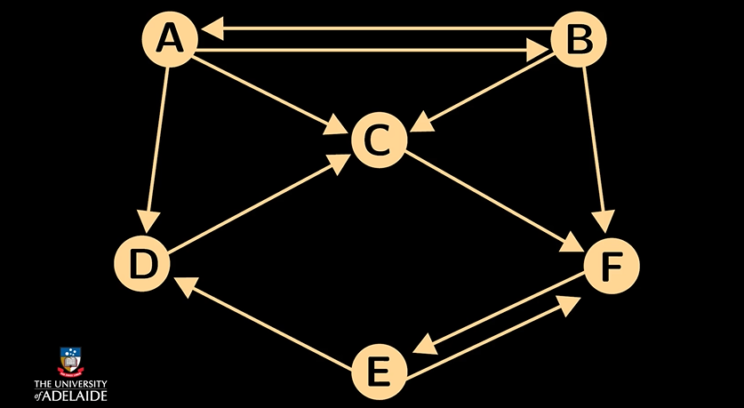

* For a graph with n pages, the matrix has dimension n times n.
* In the matrix m, mij equals 1/k, if there's a link from page j to i. Where k is the total number of outgoing links from j.
* If there is no link from j to i, then mij equals zero.

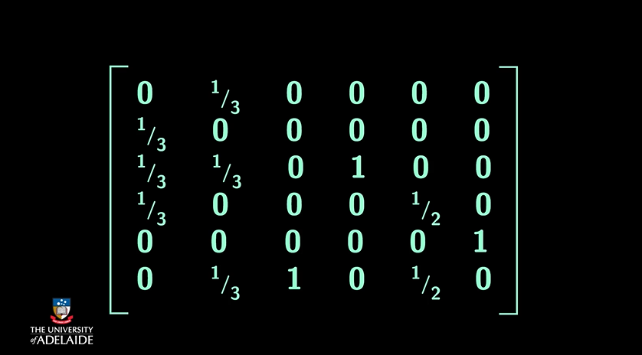

The probability distribution for the location of a random surfer can be described by a column vector of length n, where the j's component is the probability that the surfer is at page j. The probability is the idealised PageRank function. Suppose that we start a random surfer at any of the n pages.

The initial vector v0 has 1/n on each of the components.

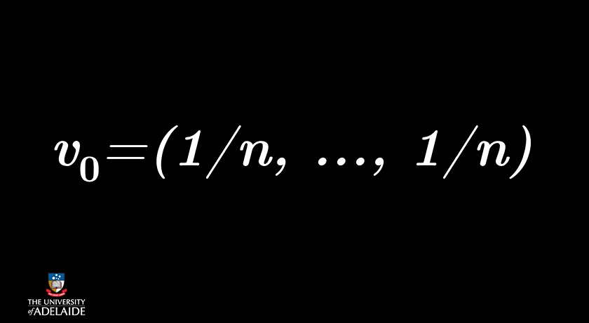

If the current distribution is v and the web transition matrix is M, then x equals M times v will be the distribution of the next step.

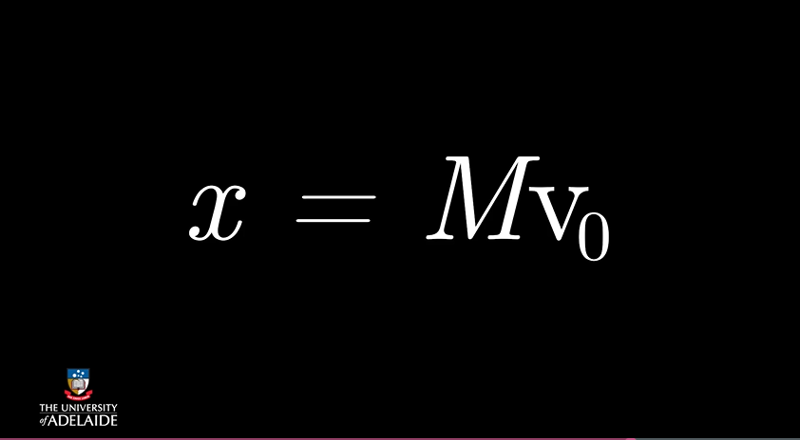

After 2 steps, on continues this way for every step.



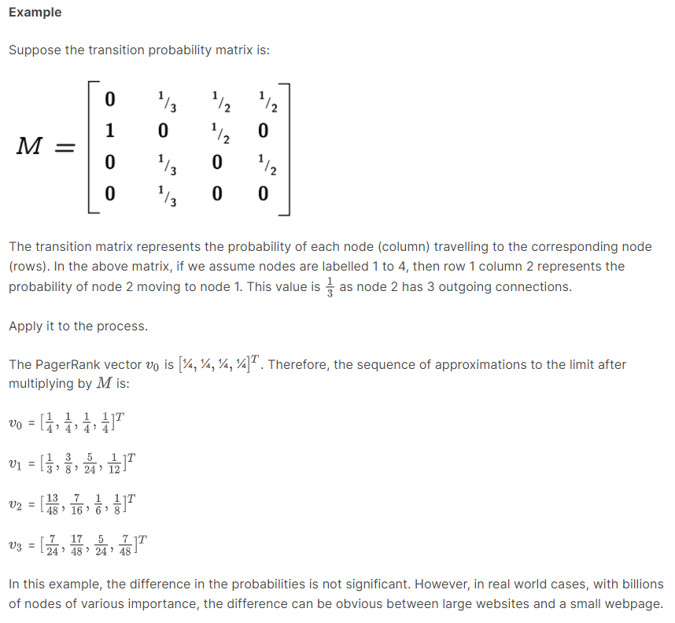

# PageRank Algorithm - Matrix Representation

<https://www.youtube.com/watch?v=kSmQbVxqOJc>

